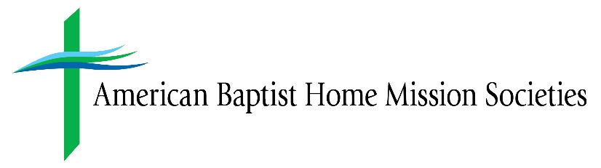

FOR IMMEDIATE RELEASE
September 20, 2022

Contact:
Peter Bickel
Director, Marketing and Communications
610-768-2047
peter.bickel@abhms.org

ABHMS Ramps up Relief for a Re-Traumatized Puerto Rico; Supports Migration of the Jackson, Mississippi, Water Crisis; and Continues Efforts to Help Struggling Kentucky Communities

VALLEY FORGE, PA (9/20/22)—In the wake of extreme weather that pummeled Kentucky, then Mississippi, and most recently Puerto Rico, American Baptist Home Mission Societies (ABHMS) is responding purposefully. Through the One Great Hour of Sharing (OGHS) fund, ABHMS manages disaster relief donations to provide financial assistance to devastated communities. ABHMS is presently mobilizing support for storm-ravaged Puerto Rico and planning a response to the water crisis in Jackson, Mississippi. Already having released $24,000 of OGHS dollars for Kentucky flood relief, ABHMS continues to seek financial support for that traumatized region.

As Hurricane Fiona was making landfall in Puerto Rico on Sunday, September 18, ABHMS was already communicating with the Rev. Edgardo Caraballo, regional executive minister of Iglesias Bautista de Puerto Rico (IBPR) on a planned response. The small island has since succumbed to widespread flooding, mudslides, and a power outage affecting a vast majority of its three million residents.

“Many hard-hit areas were still vulnerable because of the overwhelming destruction caused by Hurricane Maria five years ago,” said the Rev. Lisa Harris Lee, director of the Healing & Transforming Communities unit of ABHMS, which oversees the organization’s disaster relief. “We know many are eager to set boots on the ground there, but the greatest immediate assistance we can offer is through OGHS.” To support Puerto Rico’s recovery, please go to https://abhms.networkforgood.com/projects/170170-puerto-rico-hurricane-disaster.

Teeming August rainfall in Mississippi drove the Pearl River to flood stage, causing the water supply system for Jackson, Mississippi, to collapse. ABHMS immediately marshaled partners in the region, including Lott Carey Missionary Society; Dr. James Harrison, executive minister of American Baptist Churches of the South; and other ministry leaders in Jackson, to provide Jackson families with greater levels of support beyond immediate supplies of bottled water. For donations to ease the Jackson water crisis, please go to https://abhms.networkforgood.com/projects/170168-jackson-mississippi-water-crisis.

ABHMS continues to support relief efforts in Kentucky following a one-two punch of natural disasters—springtime tornadoes in the western part of the state and then this summer flooding in Eastern Kentucky caused by torrential rains. ABHMS has so far disbursed $34,000 into stricken Kentucky communities—$10,000 for tornado relief and more recently $24,000 in support of flood victims. The latter campaign continues to accept donations at https://abhms.networkforgood.com/projects/166180-kentucky-floods-oghs.

“ABHMS staff and its board of directors are committed to partnerships with American Baptists and others to provide recovery support,” said Dr. Jeffrey Haggray, ABHMS executive director. “We are deeply concerned and in prayer with people in all these communities. These disasters are traumatic and disruptive in ways difficult to imagine unless you have experienced them firsthand. Let’s be generous as possible in our response.”

American Baptist Home Mission Societies partners with American Baptists to promote Christian faith, cultivate Christ-centered leaders and disciples, and bring healing and transformation to communities across the United States and Puerto Rico.

American Baptist Churches USA is one of the most diverse Christian denominations today, with approximately 5,000 congregations comprised of 1.3 million members, across the United States and Puerto Rico, all engaged in God’s mission around the world.

###

